Northern Lebanon Midget Football Association | 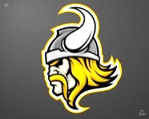
PO Box 342, Jonestown, PA 17038
Northern Lebanon Midget Football Association
Non-Profit Tax ID #91-2000223

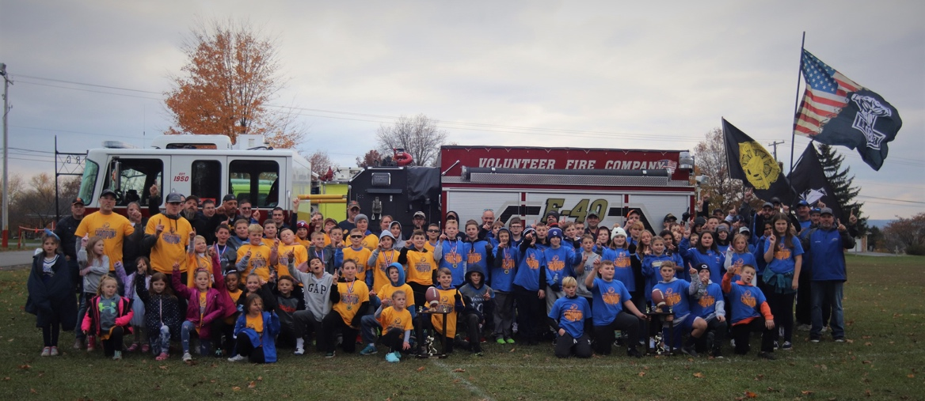
Dear Friends of the NLMFA,
It is hard to believe but we are already planning our 2023 youth football and cheerleading season. The Northern Lebanon Midget Football Association is looking forward to another great year after another successful season in 2022. Our organization provides athletic instruction to many children in our community with ages ranging from 4 to 14 by providing opportunities to play spring flag football, fall tackle football, and cheerleading. We have a dedicated and responsible staff that ensures each child is taught the principles of teamwork, sacrifice, responsibility and hard work that will not only help them be great teammates, but also valuable members of our community in the future.
As our organization continues to grow and provide top-of-the-line structured programs for the children of the community, we struggle to meet an increasing yearly budget. All football players and cheerleaders participate in several fundraisers throughout the season to assist with costs that we incur such as uniforms, equipment, insurance, officiating, and league fees. We also utilize a refreshment stand during our home games and practices to assist in additional revenue for our programs. Even with all of this, there is still a great need for sponsorships from our local community businesses and friends. Without the help of community businesses and individuals, we cannot continue to honor a tradition that was set forth so many years ago for the youth of our community.

Would you, as a business owner or individual, consider helping us in our mission to provide a safe and rewarding sporting environment for the youth of our community by becoming a business sponsor of our program? Let me explain the benefits of your tax-deductible sponsorship. We provide each participant in our organization a keepsake program. In this program, we include prominent advertisements for the businesses of all of our generous sponsors. All sponsors will also be recognized on our website at www.nlmfa.com, which derives a great deal of traffic, approximately 16,000 hits last year, from not only families in our organization but families throughout our 32 team league. We also like to announce our sponsors during our games and also on our Social Media pages.

If you have any questions, please feel free to contact our organization President, Phil Shirk at (717)304-0293. Thank you in advance for your generosity.

Sincerely,
Phil Shirk
President Northern Lebanon Midget Football Association

VIKING SPONSOR ($500 +)

- Business name on back of our preseason shirts that all of our players and coaches wear
- Business advertisement and link featured on every page of NLMFA website
- Banner featured at all of our home games
- Sponsorship plaque
- Full page ad in season program
- Special mention during all of our fundraising events, home games, and on social media

TOUCHDOWN SPONSOR ($400)

- Business advertisement and link featured on every page of NLMFA website
- Banner featured at all of our home games
- Sponsorship Plaque
- Full page ad in season program
- Special mention during all of our fundraising events, home games, and on social media

GOLD SPONSOR ($200)

- Business advertisement listed on NLMFA website with link to your website
- Sponsorship plaque
- Half page ad in season program
- Special mention during all of our and home games

BLUE SPONSOR ($100)

- Business advertisement listed on NLMFA website with link to your website
- Quarter page ad in season program

$___________OTHER AMOUNT

- Business advertisement listed on NLMFA website with link to your website
- Business card size ad in season program

Plaque opt out for Gold, Touchdown, and Viking Sponsors. Cost to be donated back to the NLMFA.

- Please make checks payable to NLMFA
- Please include a business card or letterhead showing how you would like your ad
displayed. you can also email your ad to keycomp@comcast.net (Include your business name
and “NLMFA Sponsorship” in your email title)
- Please mail this completed form to: NLMFA, P.O. Box 342, Jonestown, PA 17038

Business Name:__________________________________________________________________________
Contact Person:_______________________ _______________Phone Number:_______________________

